Second Order Sources

Before: You will be critically analyzing images from the frontier and responding to a series of questions. Images are shared below the questions. You will be analyzing ONE image at a time.
During: Take 1 minute (teacher will let students know when time is up) to look at the image. Look at all aspects-the foreground, the background, the weather, people in the image. After the teacher has called the time, create a list comprised of aspects of the photograph that stood out to you:

After we have discussed our lists as a class, respond to the questions in detail:
- Describe the environment.

- Who or what are prominent figures in the image? Where are they located in the frame? In comparison to each other? What is the purpose behind the positioning?

- Describe the fence (if there is one in the image).

- What might the fence tell us about the owners of the property? (Skip if there is no fence in the image)

- What kind of emotions does this image evoke? Why?

- Based on the information gained from what is “inside” the frame, what may be “outside” of the frame?

- What does the purpose of the fencing in each of the images appear to be? Use evidence from the image to defend your answer.

- Consider the locations of each of these images. How may the locations potentially lead us to a biased opinion regarding cowboys and the use of barbed wire?

After: Share answers with partner. What information does this add to our understanding of the impact of cowboys on the American frontier? List 3 bullet points below.

Image 1: “Cattle on the Mack Downey ranch on the South Loop River near Georgetown, Custer County, Nebraska”
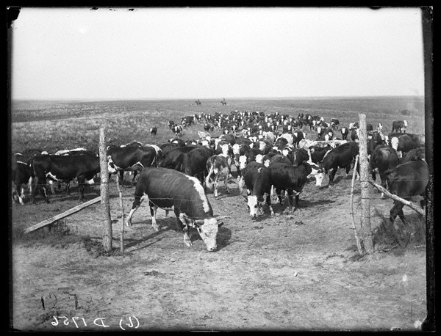
Image 2: “M.L. Marsh, West Union, Custer County, Nebraska”
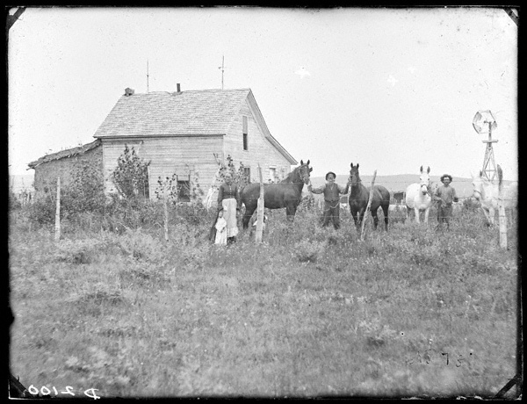
Image 3: Image: “John Hohman sod house and stock, Woods Park, Custer County, Nebraska”
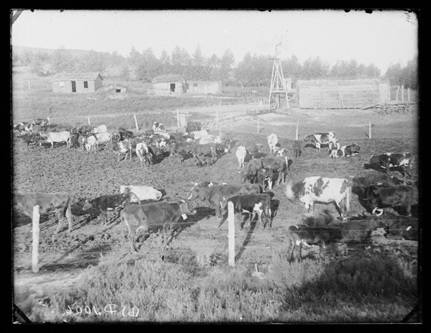
Image 4 : “R.J. Kelley’s livestock in the hills near Merna, Custer County, Nebraska”
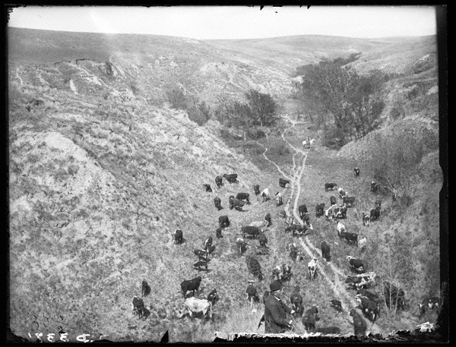

“United States Patent Office...Improvement in Machines for Making Wire Fences”
Before: The following document will provide you with background information regarding the improvement of the barbed wire fence, including new inventions included in the improvement.
During: As you read, annotate the following on your documents:
- The purpose of the document
- The authors of the document and creators of the invention
- Technical aspects or an explanation of how the machine works
After: Look at the images in the following document, “J.F. Glidden and P.W. Vaughan: Machines for Making Wire-Fences.” Reread the third paragraph (beginning with “Our invention is designed…”) and read through the end of the fifth paragraph (beginning with “The spring keeper…”). How do the images help to better understand the technicalities of how the machine works? Consider the purpose of a fence. Why might the creators/authors have felt the need to patent a barbed wire fence for the use in the Midwest (as opposed to stone or wooden fences)? How might this impact cattle being driven or herded across the country?
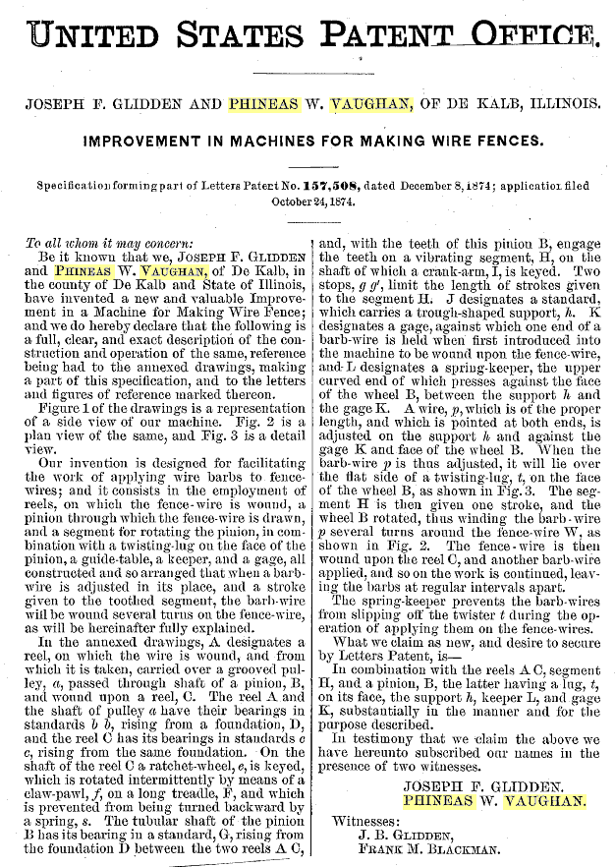

Image: “J.F. Glidden & P.W. Vaughan: Machines for Making Wire-Fences”
This document should be viewed AFTER students have read through the patent description once. Follow the instructions listed in the previous document.
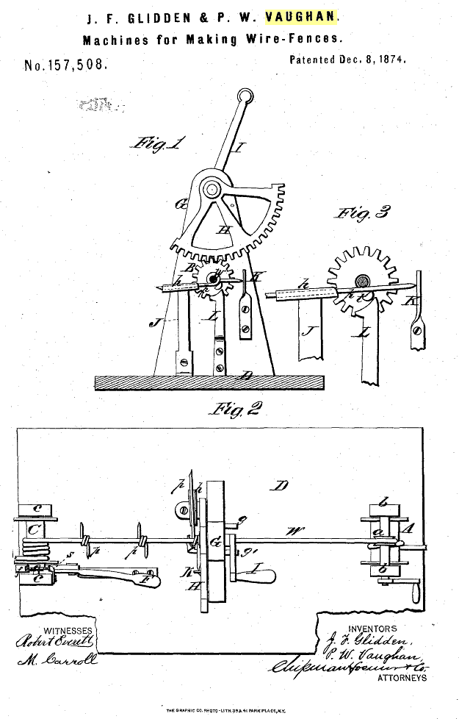
Image: “1874 Patent Model”
Before: The next image you will be analyzing is an example of material culture. It is a model of the machine Glidden and Vaughan were applying to patent. The purpose of the machine is to create barbed wire fencing. You will be answering a series of analysis questions in a graphic organizer as you analyze the image.
During: Complete the graphic organizer below as you analyze the image.

Step 1: Describe the object objectively (without emotions/feelings). Respond to the following questions.
- Describe the object in detail.
- Using your background knowledge, what was the purpose of this object?
- What kind of person (detailed explanation) might use this object? Under what conditions?
- Is this object functional or decorative? What details provide evidence?
- What materials were used to create the object?
- How may the materials used provide us with further information about the object?
Step 2: Begin to engage the object on a sensory level. Respond to the following questions.
- How would it feel, physically and emotionally, to engage with this object?
- What type of mood might a person be in when using this object? Why?
- What type of mood might a person be in when they see the result of the object (i.e., the creation of what the machine intends to do)? How might the end result impact others?
Step 3: Using your observations, write down 3 speculations you can imagine regarding the patent model.
1.

2.

3.

After: Respond to the following questions in bulleted format. Provide 2-3 bullets for each question.
How does a different analytical approach change the information you are able to gather from the image of material culture?

How does focusing on the object as “material culture” change your analysis from if you were simply looking at it as a picture?

How does this analysis provide you with more insight into the purpose of the machine?

